COGNIZANT DIGITAL NURTURE 5.0 – DEEP SKILLING PHASE
WEEK 1 : Data Structures and Algorithms – Mandatory Exercises
Submitted By
Name: Priyanshu Shekhar
Superset ID: 8011160
Email: shekharpriyanshu21@gmail.com
University: C. V. Raman Global University, Odisha

Exercise 2: E-commerce Platform Search Function
Scenario:
You are working on the search functionality of an e-commerce platform. The search needs to be optimized for fast performance.
Steps:
- Understand Asymptotic Notation:
  - Explain Big O notation and how it helps in analyzing algorithms.
  - Describe the best, average, and worst-case scenarios for search operations.
- Setup:
  - Create a class Product with attributes for searching, such as productId, productName, and category.
- Implementation:
  - Implement linear search and binary search algorithms.
  - Store products in an array for linear search and a sorted array for binary search.
- Analysis:
  - Compare the time complexity of linear and binary search algorithms.
  - Discuss which algorithm is more suitable for your platform and why.\

CODE:-
using System;

class Product
{
public int ProductId;
public string ProductName;
public string Category;

public Product(int id, string name, string category)
{
ProductId = id;
ProductName = name;
Category = category;
}

public void Display()
{
Console.WriteLine($"ID: {ProductId}, Name: {ProductName}, Category: {Category}");
}
}

class Program
{
// Linear Search
static Product LinearSearch(Product[] products, string target)
{
foreach (Product product in products)
{
if (product.ProductName.Equals(target, StringComparison.OrdinalIgnoreCase))
{
return product;
}
}
return null;
}

// Binary Search
static Product BinarySearch(Product[] products, string target)
{
int left = 0;
int right = products.Length - 1;

while (left <= right)
{
int mid = (left + right) / 2;

int result = string.Compare(
products[mid].ProductName,
target,
StringComparison.OrdinalIgnoreCase);

if (result == 0)
return products[mid];

if (result < 0)
left = mid + 1;
else
right = mid - 1;
}

return null;
}

static void Main()
{
// Product array sorted by ProductName
Product[] products =
{
new Product(101, "Laptop", "Electronics"),
new Product(102, "Mouse", "Accessories"),
new Product(103, "Phone", "Electronics"),
new Product(104, "Speaker", "Audio"),
new Product(105, "Tablet", "Electronics")
};

Console.WriteLine("===== Available Products =====\n");

foreach (Product p in products)
{
p.Display();
}

string searchItem = "Phone";

Console.WriteLine($"\nSearching for: {searchItem}\n");

// Linear Search
Product linearResult = LinearSearch(products, searchItem);

Console.WriteLine("===== Linear Search Result =====");

if (linearResult != null)
{
Console.WriteLine("Product Found!");
linearResult.Display();
}
else
{
Console.WriteLine("Product Not Found!");
}

// Binary Search
Product binaryResult = BinarySearch(products, searchItem);

Console.WriteLine("\n===== Binary Search Result =====");

if (binaryResult != null)
{
Console.WriteLine("Product Found!");
binaryResult.Display();
}
else
{
Console.WriteLine("Product Not Found!");
}
}
}

OUTPUT:- 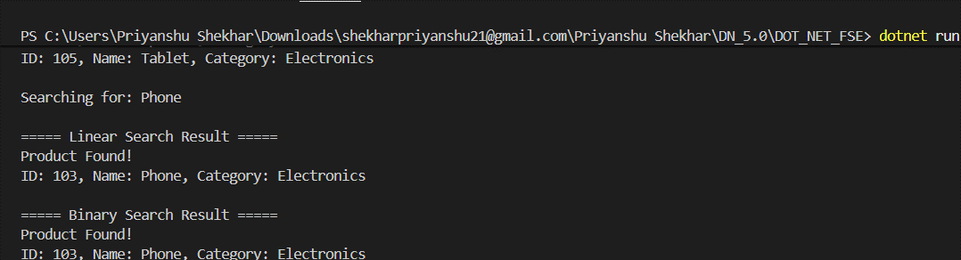

Exercise 7: Financial Forecasting
Scenario:
You are developing a financial forecasting tool that predicts future values based on past data.
Steps:
- Understand Recursive Algorithms:
  - Explain the concept of recursion and how it can simplify certain problems.
- Setup:
  - Create a method to calculate the future value using a recursive approach.
- Implementation:
  - Implement a recursive algorithm to predict future values based on past growth rates.
- Analysis:
  - Discuss the time complexity of your recursive algorithm.
  - Explain how to optimize the recursive solution to avoid excessive computation.
CODE:-
using System;

class FinancialForecast
{
// Recursive method to calculate future value
static double PredictFutureValue(double currentValue, double growthRate, int years)
{
if (years == 0)
return currentValue;

return PredictFutureValue(
currentValue * (1 + growthRate),
growthRate,
years - 1);
}

static void Main()
{
double currentValue = 10000; // Initial amount
double growthRate = 0.10; // 10% annual growth
int years = 5;

Console.WriteLine("===== Financial Forecasting =====");
Console.WriteLine($"Current Value : Rs. {currentValue}");
Console.WriteLine($"Growth Rate : {growthRate * 100}%");
Console.WriteLine($"Years : {years}");

double futureValue = PredictFutureValue(
currentValue,
growthRate,
years);

Console.WriteLine($"\nPredicted Future Value after {years} years = Rs. {futureValue:F2}");
}
}

OUTPUT:-
